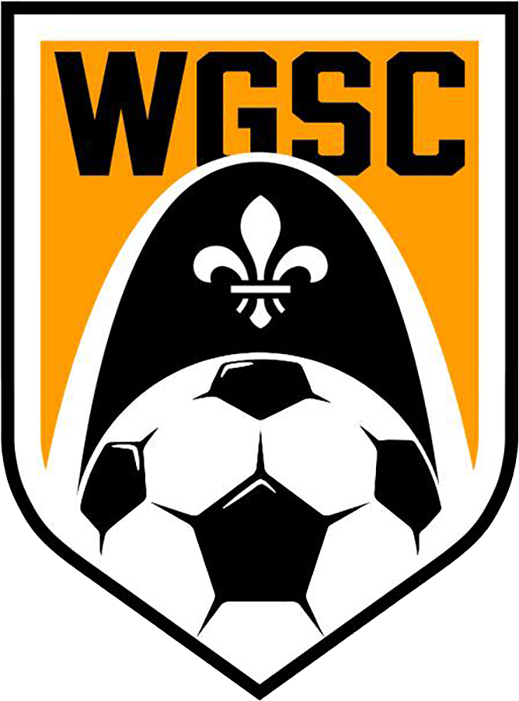

REFUND REQUEST FORM
The Webster Groves Soccer Club (WGSC) is a non-profit organization and the Club strives to maintain the lowest possible registration fees while ensuring that our members receive the highest level of soccer programming possible. The Club incurs an administrative cost for each player during registration including but not limited to staffing, credit card and debit fees, equipment, and other expenditures. Refunds also impact the program, team, other participants, and their families associated with the same commitment made when registering for a program offered. It is because of these far-ranging impacts that cover costs attributed to the commitment made and the registration received that the WGSC adheres to a strict refund policy. To receive a refund from the Club, the parent must fill out the refund request form completely and within specified time constraints.

CLICK HERE to submit your refund request form.

REFUND POLICY
The Webster Groves Soccer Club (WGSC) adheres to a strict refund policy. To receive a refund from the Club, the parent, guardian or participant must complete a Refund Request Form within the specified time period. Refund Request Forms may be obtained from the Club office during regular business hours.
The Refund Request will be reviewed based on the date the Refund Request Form is received via email webstergrovessc@sportsoffice365.com. Refunds will be issued via credit or debit card credits. This policy applies to all registration fees paid directly to Webster Groves Soccer Club (WGSC). WGSC will not be responsible for any funds paid to a team, team coach, team official, or any funds raised and collected by teams through sponsorship or fundraising. No refunds will be issued for sessions canceled due to severe weather or facility closures.
See our website for more information about our refund policy.
1- YOUTH ACADEMY & IN-HOUSE LEAGUE REFUNDS
a) ALL REFUNDS are subject to a $40.00 Administration Fee
b) There will be no refunds/transfer of registration fees from 10 days prior to the start of the season.
c) If a club uniform kit has been ordered and/or received by the player, the refund policy of Soccer Master or the vendor used applies in all situations. If a refund is not available via Soccer Master or the vendor used, it must be returned in good order (“new” - unworn, unsoiled or stained, not torn, and tags not removed) for a 50% refund to be considered by WGSC.
d) If a player needs to withdraw due to medical reasons, the request for a refund form and medical documentation must be received within 10 days of the injury occurrence. Players will receive a partial refund (pro-rated) for any medical issues that occurred prior to 50% of completion of the season. There are no refunds if more than 50% of the season has occurred.
e) There will be no refund of any fees if a parent or player is suspended or expelled from WGSC under the club’s discipline policy or code of conduct policy or that of one of our governing bodies.
f) There are no refunds for cancellations, postponements, reduction of total time, or rescheduling of events due to weather.
g) A full refund will be issued if WGSC is unable to field a team or provide a reasonable program alternative. No administrative fee will be applicable.
2- SELECT/COMPETITIVE (SANCTIONED) TEAMS: PRIMARY ROSTER & SECONDARY ROSTER
a) There will be no refunds/transfer of registration fees, including the initial payment to secure the player’s spot in the Select/Competitive Program. If a player needs to withdraw due to medical reasons, the request for a refund form and medical documentation must be received within 10 days of the injury occurrence. Players will receive a partial refund (prorated) for any medical issues incurred prior to 50% of completion of the team’s program. There are no refunds if more than 50% of the program has occurred.
b) There will be no refund if a parent or player disagrees with the coach, team, or tier placement the player has been assigned.
c) If a uniform has been ordered and/or received by the player, the refund policy of Soccer Master or the vendor used applies in all situations. If a refund is not available via Soccer Master or the vendor used, it must be returned in good order (like “new” - unworn, unsoiled or stained, not torn, and tags not removed for a 50% refund to be considered by WGSC.
c) If families have a balance owing to the WGSC when a player withdraws, players will not be released until that balance has been paid.
d) Refunds of any team-level charges or fees agreed upon by the parent(s) that originated with the team will be handled by the individual teams. These fees collected at the team level will be handled by the individual teams and are in no way a substitute for the payment of club fees.
e) There are no refunds of any fees if a parent or player is suspended or expelled from the WGSC under the Club’s Discipline Policy or Code of Conduct Policy or that of one of our governing bodies.
f) As a convenience to its members, WGSC offers payment plans for its Select/Competitive teams. It may be the case that depending on the timing of the withdrawal of a player on a payment plan, there may still be an amount owing to WGSC.
g) There are no refunds for cancellations, postponements, reduction of total time, or rescheduling of events due to weather.
h) A full refund will be issued if WGSC is unable to field a team or provide a reasonable program alternative. No administrative fee will be applicable.
i) Tournament Team Fees are part of the overall club fees paid and are required by all players no matter their playing status at the event's time.
3- Camps, Clinics, & Other Special Events requiring Pre-Registration.
a) ALL REFUNDS are subject to a $20.00 Administration Fee
b) If a player needs to withdraw due to medical reasons, the request for a refund form and medical documentation must be received within 10 days of the injury occurrence. Players will receive a partial refund (pro-rated) for any medical issues incurred prior to 50% of completion of the program. There are no refunds if more than 50% of the program has occurred.
c) There are no refunds of any fees if a player or parent is suspended or expelled from the WGSC under the Club’s Discipline Policy or Code of Conduct Policy or that of one of our governing bodies.
d) There are no refunds for cancellations, postponements, reduction of total time, or rescheduling of events due to weather.

4- RECREATIONAL (NON-SANCTIONED) TEAMS, PLAYERS, & LEAGUES
a) ALL REFUNDS are subject to a $100 Administration Fee
b) If a club uniform kit has been ordered and/or received by the player, the refund policy of Soccer Master or the vendor used applies in all situations. If a refund is not available via Soccer Master or the vendor used, it must be returned in good order (“new” - unworn, unsoiled or stained, not torn, and tags not removed) for a 50% refund to be considered by WGSC.
c) If families have a balance owing to the WGSC when a player withdraws, the player will not be released until that balance has been paid.
d) Refunds of any team-level charges or fees agreed upon by the parent(s) that originated with the team will be handled by the individual teams. These fees collected at the team level will be handled by the individual teams and are in no way a substitute for the payment of club fees.
e) If a player needs to withdraw due to medical reasons, the request for a refund form and medical documentation must be received within 10 days of the injury occurrence. Players will receive a partial refund (pro-rated) for any medical issues incurred prior to 50% of completion of the program. There are no refunds if more than 50% of the program has occurred.
f) There will be no refund if a parent or player disagrees with the coach, team, or tier placement the player has been assigned.
g) There are no refunds of any fees if a player or parent is suspended or expelled from the WGSC under the Club’s Discipline Policy or Code of Conduct Policy or that of one of our governing bodies.
h) As a convenience to its members, WGSC offers payment plans for its Recreational Team players. It may be the case that depending on the timing of the withdrawal of a player on a payment plan, there may still be an amount owing to WGSC.
i) There are no refunds for any cancellations or postponements or rescheduling of events due to weather.
j) A full refund will be issued if WGSC is unable to field a team or provide a reasonable program alternative. No administrative fee will be applicable.

